STATISTICAL ANALYSIS PLAN

An academic performance analysis by Dennis CL, and James S.

# Aim of Study

* The aim of this study is to determine significant factors that influence the grades of students in secondary education in two Portuguese schools utilizing analysis of variance methods.
* Describe how academic performance is influenced by several of the following factors:
  + Mother’s Profession
  + Having Previously Failed a Class
  + Time allocated to studying

# Research Questions

Amongst students within secondary education in two Portuguese schools:

1. Is there a significant difference in the average final grade between students’ with varying mother’s profession, students who have failed a class, or perhaps any interaction between the two categories?
2. Does the weekly study time have an impact on final academic performance among Portuguese secondary students?

# The Data

Two datasets are present in this analysis. One in which returns students’ final mathematics grade, and another which includes students final Portuguese Language grade. Both datasets include observations from two schools, collected via school reports and questionnaires. The following variables are included in both datasets also:

|  |  |  |  |
| --- | --- | --- | --- |
| **Variable** | **Description** | **Variable** | **Description** |
| school | Student's school (GP or MS) | sex | Student's sex (Female or Male) |
| age | Student's age | address | Home address type (Urban or Rural) |
| famsize | Family size (≤3 or >3 members) | Pstatus | Parent’s cohabitation status (Together or Apart) |
| Medu | Mother's education level | Fedu | Father's education level |
| Mjob | Mother's profession | Fjob | Father's profession |
| reason | Reason for choosing the school | guardian | Student's guardian (Mother, Father, Other) |
| traveltime | Time to travel from home to school | studytime | Weekly study time |
| failures | Number of past class failures | schoolsup | Extra educational support (Yes/No) |
| famsup | Family educational support (Yes/No) | paid | Extra paid subject classes (Yes/No) |
| activities | Participation in extracurricular activities | nursery | Attended nursery school (Yes/No) |
| higher | Intends to pursue higher education | internet | Internet access at home (Yes/No) |
| romantic | In a romantic relationship (Yes/No) | famrel | Quality of family relationships |
| freetime | Free time after school | goout | Frequency of going out with friends |
| Dalc | Weekday alcohol consumption | Walc | Weekend alcohol consumption |
| health | Current health status | absences | Number of school absences |
| G1 | First period grade | G2 | Second period grade |
| G3 | Final grade |  |  |

## The Data Transformations

**Portuguese Data**

To prepare the data for analysis, I filtered out all rows with missing values in studytime or G3(final grade) using R filter functions to ensure complete cases for the ANOVA model. Converted studytime into a factor, treating it as a categorical variable with four levels

* 1: <2 hours/week
* 2: 2-5 hours/week
* 3: 5-10 hours/week
* 4: >10 hours/week

Ensured G3 was numeric, allowing it to be used as a continuous response variable in the model.

**Math Data**

The data for math scores was transformed by recoding the reported number of prior class failures into a new categorical variable indicating whether a student had ever failed a class or not. This binary variable was used to distinguish between students with no history of failure and those who had failed at least one class. After removing and NA’s and grade scores of zero—as zero values were viewed to be extraneous circumstances or outliers—the data was then filtered to select only the variables of concern:

|  |  |  |
| --- | --- | --- |
| Variable | Description | Type |
| Student ID | ID of student | Numeric |
| Mother’s Profession | Reported job of mother | Categorical |
| Math Final Grade | Final Grade Measurement | Numeric |
| Prior Class Failure Indicator | Indication of failing prior class | Categorical |

After the filtering a two-way ANOVA test was performed. This method was appropriate because it allows for the comparison of mean values across multiple categorical groups while accounting for the combined effects of the two independent variables.

# Analysis Methodology

**Portuguese Analysis Methodology**

Used one-way ANOVA to test whether the mean final grade (G3) differs across the four study time categories. We will look at p-value for our hypothesis testing:

Null Hypothesis ($H_{0}$): Students' average final grades are the same across all study time categories.

$$H_{o}: μ_{1}=μ_{2}=μ_{3}=μ_{4}$$

Alternative Hypothesis ($H_{A}$): At least one study time group has a significantly different average final

$$H_{A}:At leanst one μ_{i} does not equal$$

Post-hoc analysis was conducted using Tukey’s Honest Significant differences to determine which study time groups significantly differed.

**Math Analysis Methodology**

For this analysis a two-way ANOVA was implemented to determine significant differences between each of the proposed variables (Mother’s Job, Previous Failures). After obtaining the results, a Tukey-HSD post hoc analysis was performed to assess which levels of mother’s profession showed the most significant differences.

Hypotheses for Mother’s Profession:

Null: The average final math grade is the same for students regardless of their mother’s profession.

$$H_{0}: μ_{At_{Home}}=μ_{Other}=…=μ_{teach}$$

Alternative: At least two of the average grades differ significantly between students based on their mother’s profession.

$H_{A}:$ At least 2 $μ_{i}$ are significantly different.

Hypotheses for Prior Failed Classes:

Null: The average final math grade is the same for students who have failed a prior class and those who have not.

$$H_{0}: μ_{1}=μ_{2}$$

Alternative: The average final math grade differs between students who have failed a prior class and those who have not.

$H_{A}:μ_{1}≠μ_{2}$

Hypotheses for Interaction Term:

Null: There is no interaction effect between mother’s profession and prior class failure on a student’s average final math grade.

$H_{0}:$ No significant interaction exists

Alternative: There is a significant interaction between mother’s profession and prior class failure affecting the student’s average final math grade.

$H_{A}:$ Significant interaction exists

# Results

**Portuguese results**

The ANOVA output is as follows:

|  |  |  |  |  |  |
| --- | --- | --- | --- | --- | --- |
| **Source** | **Df** | **Sum Sq** | **Mean Sq** | **F value** | **Pr(>F)** |
| **studytime** | **3** | **465.0778** | **155.025942** | **15.87627** | **0.0000000005705728** |
| **Residuals** | **645** | **6,298.1887** | **9.764634** |  |  |

The p-value is extremely low (< 0.001), indicating strong statistical evidence that students’ final grades significantly differ across at least one of the study time categories. Therefore, we reject the null hypothesis ($H_{o}: μ_{1}=μ_{2}=μ_{3}=μ_{4}$ ​) in favor of the alternative hypothesis. This result suggests that the amount of time a student studies per week has a statistically significant effect on their academic performance, specifically their final grade in the Portuguese course.

**The results of the pairwise comparisons Tukey HSD are summarized below:**

|  |  |  |  |  |
| --- | --- | --- | --- | --- |
| **Group Comparison** | **Mean Diff** | **Lower CI** | **Upper CI** | **p adj** |
| 2-1 | 1.2474637 | 0.5277536 | 1.967174 | 0.000055903309056 |
| 3-1 | 2.3824645 | 1.3958316 | 3.369097 | 0.000000005071332 |
| 4-1 | 2.2128032 | 0.7442940 | 3.681312 | 0.000661204013346 |
| 3-2 | 1.1350008 | 0.1967750 | 2.073227 | 0.010310666015165 |
| 4-2 | 0.9653396 | -0.4710944 | 2.401774 | 0.308388539096400 |
| 4-3 | -0.1696613 | -1.7567354 | 1.417413 | 0.992703643234281 |
| Pairwise Tukey-adjusted comparisons at 95% confidence level | | | | |

Students who studied less than 2 hours per week (group 1) had significantly lower final grades compared to students in all other groups. However, no significant difference was found between groups 3 and 4, indicating that increasing study time beyond 10 hours/week may not lead to a further grade increase.

**Figure 1. Mean Final Grade by Study Time Category (with 95% CI)**

This graph shows an upward trend in final grades with increasing study time, especially between categories 1 to 3. Error bars indicate 95% confidence intervals.

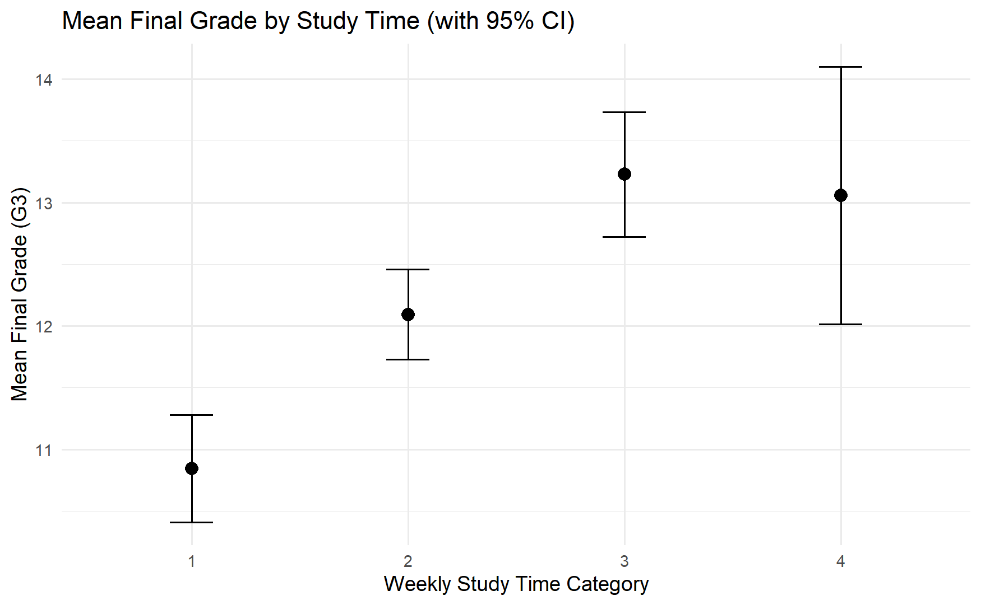

**Math Analysis Results:**

After analyzing the transformed data with a two-way ANOVA test, the results showed statistical significance amongst the mean scores between both Mother’s Profession and Prior Class Failures. However, the interaction between the two has not resulted in a significant p-value. The test output is as follows:

|  |  |  |  |  |
| --- | --- | --- | --- | --- |
| Variable | numDF | denDF | F-value | p-value |
| (Intercept) | **1** | **347** | **5172.980** | **<.0001** |
| Mjob | **4** | **347** | **4.662** | **0.0011** |
| Fail | **1** | **347** | **32.579** | **<.0001** |
| Mjob:Fail | **4** | **347** | **1.621** | **0.1685** |

Based upon the output above, given $P=0.0011<0.05,$ and $F=4.662$ relating to Mother’s Profession, we can reject $H_{0}$ in favor of $H_{A}$. Therefore we can say with 95% confidence that a Portuguese student’s average final math grade is significantly different between students in which their mother has different professions.

Continuing to a Tukey HSD post hoc analysis of these results, we can determine where the largest differences in average final math score lie. The output of said post hoc analysis is as follows:

|  |  |  |  |
| --- | --- | --- | --- |
| **Comparison** | **coefficients** | **tstat** | **pvalues** |
| **services - at_home** | **2.0925307** | **3.4503014** | **0.004895663** |
| **services - other** | **1.5639869** | **3.3398871** | **0.007169480** |
| **health - at_home** | **2.4652015** | **3.2875061** | **0.008713679** |
| **other - health** | **-1.9366577** | **-3.0107358** | **0.021095688** |
| **teacher - health** | **-1.3049451** | **-1.8389425** | **0.343993377** |
| **teacher - at_home** | **1.1602564** | **1.8092871** | **0.360873297** |
| **teacher - services** | **-0.9322742** | **-1.6769397** | **0.440823651** |
| **teacher - other** | **0.6317126** | **1.2324969** | **0.726463958** |
| **other - at_home** | **0.5285438** | **0.9322286** | **0.881293199** |
| **services - health** | **-0.3726708** | **-0.5493932** | **0.981449403** |

Based upon the Tukey HSD output above, we can see that the largest differences lie between the following mothers’ professions:

* Services & At-Home
* Services & Other
* Health & At-Home
* Other & Health

Based upon the two-way ANOVA output, given $P<0.0001<0.05,$ and $F=32.579$ relating to a student having failed a prior class, we can reject the relative $H_{0}$ in favor or $H_{A}$. Therefore, we can say with 95% confidence that a Portuguese student’s average final grade is significantly different between students who have failed a prior class, and students who have never failed a prior class.

Based upon the two-way ANOVA output, given $P=0.1685>0.05,$ and $F=1.621$ relating to the interaction term between mother’s profession and prior class failure, we cannot reject the relative $H_{0}$ in favor or $H_{A}$. Therefore, we cannot say that a Portuguese student’s average final grade is significantly affected by any interaction between the two independent variables.

A visualization of the student’s average math scores for each level of analysis follows:

# Conclusion

**Portuguese Conclusion**

This analysis examined whether weekly study time impacts students’ final grades in Portuguese. The results showed a strong statistical difference between groups, allowing us to reject the null hypothesis. Students who studied more than 2 hours per week consistently performed better than those who studied less, with the most notable improvement seen between the lowest and moderate study groups. However, there was no significant gain in performance when study time increased beyond 10 hours per week.

These findings carry practical implications for both students and educators. Encouraging at least moderate study habits can lead to meaningful improvements in academic performance, especially for those currently studying very little.

While the results are compelling, it's important to note that this analysis is based on observational data. Therefore, while we found a strong association between study time and grades, we cannot definitively claim a causal relationship. Other factors—such as motivation, learning environment, or access to resources—may also contribute to academic outcomes.

In conclusion, our analysis supports the idea that study habits play an important role in academic success. Students who invest more time into studying each week tend to achieve higher final grades, particularly when moving from minimal study to moderate levels. This insight can help guide both personal study strategies and educational policy decisions aimed at improving student performance.

**Math Conclusion**

To address the research question of whether there is a significant difference in the average final grade based on Mother’s Profession, Prior Class Failures, or their interaction, a two-way ANOVA was conducted. The analysis showed significant main effects for both Mother’s Profession and Prior Class Failures, indicating that each factor independently impacts student performance. However, the interaction between the two was not statistically significant, suggesting that the effect of a mother's profession on grades does not vary based on whether a student has previously failed a class.

Follow-up analysis using Tukey HSD revealed that differences in average final grades were most pronounced between certain maternal professions, particularly those in services, healthcare, at-home, and other categories. These results confirm that the average final grade varies significantly with both a student’s academic history and their mother’s occupation, though not in combination.

One particularly interesting finding—which can be seen in the visualization of average math scores above—is that students who had previously failed a class had average scores below the national Portuguese passing threshold of 10 out of 20, regardless of their mother's profession. On the other hand, students with no history of failure generally had average scores above this threshold. This may suggest that prior academic struggles may have a lasting negative effect on student performance and perhaps highlights potential value in early academic support or intervention.

Regarding limitations of this analysis, it is important to note that this analysis is based on observational data, so while we can spot patterns and relationships, we can’t say for sure that one factor directly causes another. For example, we found links between student’s academic history and their mother’s job, but we can’t say those factors are the reason for the differences. Also, because some of the information was self-reported, implying that there’s a chance it may not be completely accurate. These are important things to consider when thinking about how these results might apply to students outside of this dataset.

# GitHub Information

<https://github.com/Dennis-LCLema/STAT_301_FInalProject>